Project - High Level Design
On
Multimodel Insurance Creator
  - Course Name: Gen AI

Institution Name: Medicaps University – Datagami Skill Based Course

Student Name(s) & Enrolment Number(s):
Sr no | Student Name | Enrolment Number
1 | Ishita Garg | EN22CS301446
2 | Ishita Jain | EN22CS301447
3 | Janvi Mahajan | EN22CS301455
4 | Janak Dalke | EN22CS301452
5 | Irya Patni | EN22CS301436

Group Name: D404
Project Number: GAI-40
Industry Mentor Name:
University Mentor Name : Prof. Divya Kumawat
Academic Year: 2025-2026

Table of Contents
- Introduction.
  - Scope of the document.
  - Intended Audience
  - System overview.
- System Design.
  - Application Design
  - Process Flow.
  - Information Flow.
  - Components Design
  - Key Design Considerations
  - API Catalogue.
- Data Design.
  - Data Model
  - Data Access Mechanism
  - Data Retention Policies
  - Data Migration
- Interfaces
- State and Session Management
- Caching
- Non-Functional Requirements
  - Security Aspects
  - Performance Aspects
- References

1. Introduction
Understanding insurance policies can be confusing for most people because they contain complex terms and lengthy explanations. Many users struggle to interpret insurance documents properly.
To solve this problem, we developed the Multimodal Insurance Creator, an AI-based system that explains insurance concepts in a simple and clear way. Our system generates both text explanations and supporting images, which makes it easier for users to understand the topic quickly.
The main aim of this project is to make insurance knowledge more accessible and user-friendly.

2. Scope of the Document
This document explains the overall design of our system. It includes:
- How the system works
- The architecture and components
- Data handling methods
- APIs used
- Security and performance considerations
This document gives a high-level understanding of our project structure.

3. Intended Audience
This document is prepared for:
- Faculty members and evaluators
- Industry mentor
- Developers working on the project
- Anyone who wants to understand the system design

4. System Overview
The Multimodal Insurance Creator is a prompt-based AI system.
The working of the system is simple:

- The user enters a question related to insurance.
- The system processes the query using an AI language model.
- A simple explanation is generated in text format.
- A related image is created to support the explanation.
- Both text and image are shown to the user as the final output.
This combination of text and visuals helps users understand better and faster.

5. System Design
Our system follows a modular design approach. It consists of:
- User Interface
- Backend Processing System
- AI Text Generation Module
- Image Generation Module
- Output Display Module
Each part performs a specific task, and together they deliver the final result.
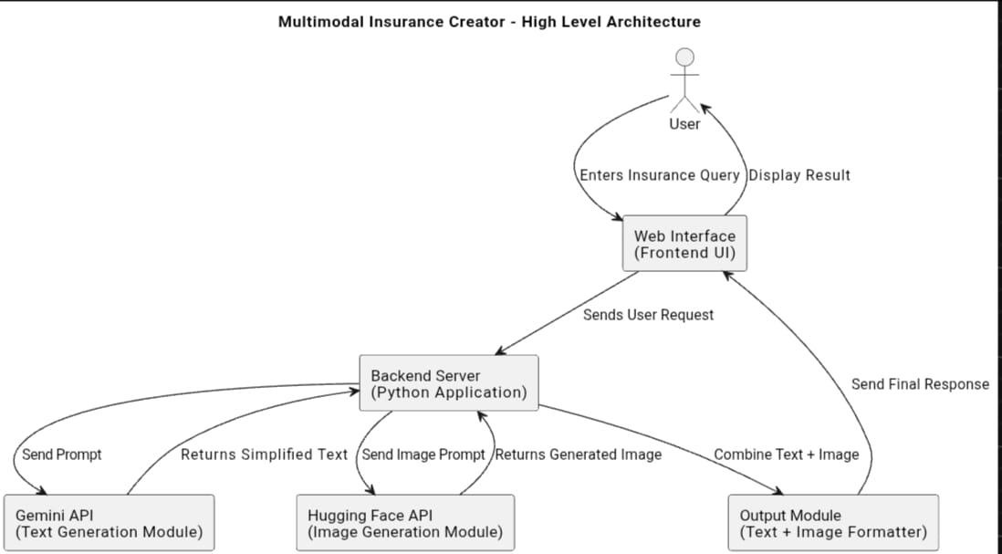

6. Application Design
The application is designed as a simple web-based system.
It includes:
- A text input field where users can type their query
- A backend built using Python
- Integration with Gemini API for text generation
- Integration with Hugging Face models for image generation
We used prompt engineering techniques to ensure the generated content is clear and relevant.

7. Process Flow
The process works in the following steps:
- User enters a query.
- The backend receives and processes the input.
- The query is sent to the Gemini API.
- The API generates a simplified explanation.
- The system generates a related image.
- The final combined output is displayed to the user.

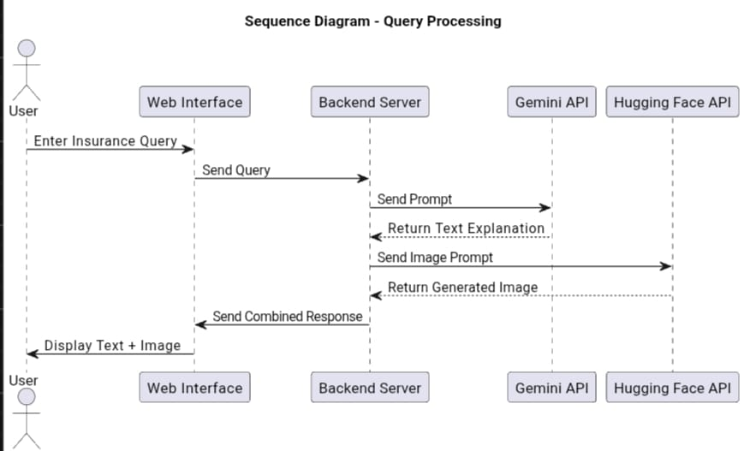

8. Information Flow
The information flows as follows:
User → Backend → AI Model → Text Output
User → Backend → Image Model → Image Output
Text + Image → Combined Response → User
The backend ensures that both outputs are properly combined before showing them.
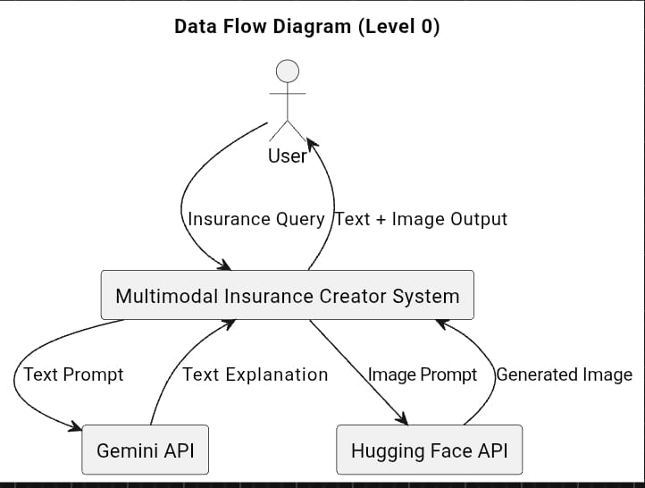

9. Components Design

1. User Interface
Allows users to enter queries and view results.

2. Backend Module
Handles user requests and manages communication with APIs.

3. Text Generation Module
Uses Gemini API to generate simplified explanations.

4. Image Generation Module
Uses Hugging Face models to generate supporting visuals.

5. Output Module
Combines and formats the final response.
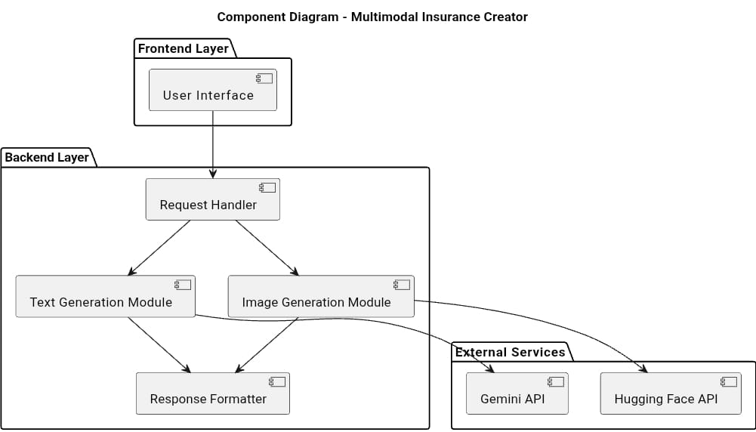

10. Key Design Considerations
While designing the system, we focused on:
- Keeping the interface simple and easy to use
- Generating clear and short explanations
- Matching images correctly with text
- Making the system scalable
- Keeping the architecture modular for future improvements

11. API Catalogue

Gemini LLM API
- Used for generating text explanations
- Takes user prompt as input
- Returns simplified text output

Hugging Face API
- Used for generating images
- Takes image prompt as input
- Returns generated image

12. Data Design
The system mainly works with dynamic data.
Types of data used:
- User queries
- Generated text explanations
- Image prompts
- Generated images
We do not store large amounts of user data.

13. Data Model
Basic structure:
User
- User ID
- Query
Response
- Response ID
- Text Explanation
- Image
- Timestamp

14. Data Access Mechanism
- Communication is done through APIs
- Data is transferred using JSON format
- Secure API keys are used for authentication

15. Data Retention Policies
- User queries are not permanently stored.
- Temporary session storage is used during processing.
- No sensitive personal information is stored.

16. Data Migration
Currently, data migration is not required because the system does not use a permanent database.
In the future, if integrated into larger platforms, cloud storage solutions may be considered.

17. Interfaces

External Interfaces
- Gemini API
- Hugging Face API

Internal Interfaces
- Backend to API communication
- Backend to User Interface communication

18. State and Session Management
- Each user request is handled independently.
- The system follows a stateless backend design.
- Sessions are maintained only during request processing.

19. Caching
- Temporary caching can be used to reduce repeated API calls.
- This helps improve system response time.

20. Non-Functional Requirements
The system should:
- Respond quickly
- Be reliable
- Be easy to use

- Handle multiple users
- Maintain system availability

21. Security Aspects
- API keys are stored securely.
- Communication is done using secure protocols (HTTPS).
- Input validation is performed to avoid misuse.
- No sensitive user data is stored.

22. Performance Aspects
- Optimized prompts for faster results
- Efficient backend processing
- Parallel handling of text and image generation
- Reduced latency through caching

23. References
- Gemini API Documentation
- Hugging Face Documentation
- Python Official Documentation
- Research on Prompt Engineering

